TEG/PV hybrid system
Student Name
Institution Affiliation
Course
Date

Abstract
Solar Photovoltaics has currently undergone technological development. The development has been evidenced in various subfields like module materials, PV cells, and manufacturing (Milichko et al., 2016). The different branches are created to increase the generation of energy. The photovoltaic module uses photon energy from solar irradiation and absorbs heat energy (Solanki, 2015). However, heat energy and power can be simply generated by using TEGs (Thermoelectric Generators). This is likely to increase the efficiency of the whole power generation system, something which has been tried for several years. Despite the prevailing advantage of using photovoltaic in energy and power generation, it has a disadvantage. It needs a strong cooling system that helps maintain the performance of the cell solar. In order to curb the problem, it is possible to implement the use of Thermoelectric Generators, which help in cooling down the temperatures in the solar cells as well as recycling the waste heat (Guerrero-Lemus et al., 2016).

Introduction
The keywords in my project are Thermoelectric generators (TEG) and concentrated Photovoltaics (PV).
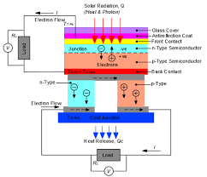
Photovoltaic cells are considered to be durable as well as capable of carrying out several operations over a long period of time. However, the performance of photovoltaic cells is also affected by a temperature increase in the operating system (Paranthaman et al., 2016). This is because the incident solar energy part is configured into electricity, and the other remaining part is also configured into heat, which ends up reducing the open-circuit voltage and therefore increasing the efficiency. In addition, waste thermal energy can be exploited by converting it to power, which increases the whole photovoltaic system efficiency (Mathews et al., 2019).
Moreover, to reduce the costs incurred in a photovoltaic system, it is recommendable to use tracking or stationery solar concentrator subsystems. Concentrator PV (CPV) has emerged as a prime approach used to expand the use and the development of photovoltaic systems, more so in locations characterized by clear sky. Currently, Concentrator Photovoltaics are more efficient. They are possible to sustain light concentration ratios on few hundreds order. However, an increase in temperature of the Concentrator Photovoltaic system operating which are under high concentration levels that are high is a big problem that faces the technology. Therefore, Concentrator Photovoltaic operations need passive or active cooling. However, this depends on the lighting concentration levels of the operation. The active cooling system has a disadvantage in that it is complex as well as energy-consuming. On the other side, passive cooling is not very efficient as compared to active cooling, even though it is not much complex and does not need energy for it to be operated ( Philipps et al., 2015).
A Concentrator photovoltaic, thermoelectric generator hybrid system is a good solution. First, this is because it gives concentrator photovoltaic cells a passive cooling system to maintain the efficiency of the solar cells at levels that are acceptable. Secondly, it uses the excess heat which is released from the concentrator photovoltaic (Ekins-Daukes et al., 2016). This is done by converting the excess heat into power which is added to the heat produced by the main concentrator photovoltaic system.
There is a study that has been performed on electrical performance, which partially illuminates TEG. The results of the conducted study are likely to give deeper insight into TEGs incorporation into a TEG/CPV system to passively reduce heat in solar cells and to enhance extra production of thermoelectric power. The process of incorporating thermoelectric devices into concentrator photovoltaic modules has called for several investigations in its studies. For instance, a hot mirror, an integrated system with a beam spectral splitter, has been studied. There is the transmission of wavelength light in the system, which is transmitted to the photovoltaic module. On the other hand, there is the transmission of longer wavelength light to the thermoelectric generators module. Moreover, a study is performed to investigate solar spectrum portioning to harvest the maximum efficiency conversion of photovoltaic to a thermoelectric hybrid system with the operating solar cell at ambient temperatures. A solar-driven hybrid generation system is a design that is integrated. It comprises a solar cell, a silicon thin-film, thermoelectric generation, and a heat collector, which has been examined. The waste heat from solar cells and incident solar energy parts are collected and used in h thermoelectric generations and used in thermoelectric generations for conversion of thermoelectric (Allouhi et al., 2015).
In recent jobs that have been conducted concerning photovoltaic and thermoelectric generations, there are several tests that have been conducted on CPV and TEG hybrid systems. The tests have been done against two varying concentrator photovoltaic known as multijunction and silicon LGBC. The results of the tests revealed that there is the maintenance of a persistent electrical output by a multijunction solar cell, which was under high levels of light that was concentrated. Also, the results showed that thermoelectric generated additional/more output power.
Thermoelectric units are modeled as well as stimulated in some studies. For example, there is modeling as well as simulation of a concentrated solar thermal. This has been done by the use of a three-dimensional finite element scheme (Powell et al., 2017). Additionally, in the study, there was the testing of three diverse geometries and comparisons that aimed to study substrate area and the geometry effect of the thermoelectric generations on the performance of the thermoelectric generations. According to the results obtained from the tests, there is an output increase for a thermoelectric element fixed-length whenever there is a decrease of the cross-sectional area.
The current found in a photovoltaic cell is related to the voltage applied by the well-known one-diode model. Because the current generated is directly proportional to solar irradiance incident, there is the use of solar concentrators to increase solar irradiance. Unfortunately, the evidenced increase in this type of incident irradiance results in elevation of the device's temperature, which reduces the output voltage of the generated current. The impact of this is that it reduces the conversion of photovoltaic conversion efficiency. There is an assessment of several models that show that there is a relationship of the photovoltaic cell to the operating temperature. For instance, there is a model used to show the relationship between the efficiency of photovoltaic and its temperature.
A multijunction (M) solar cell, which is made up of three to five compound semiconductors, is characterized by high efficiencies. Therefore, they are used in terrestrial as well as space applications. The concentrator photovoltaic utilized in this work is C1MJ, and it has an effective area of about 98.9 squared millimeters. Moreover, it has an average efficiency of about 36%, which is found under concentrated radiation of around 500 suns (Chen et al., 2015).
On the other hand, thermoelectric generators are described as potential candidates for passive cooling of concentrator photovoltaic, and it is possible to generate more energy. A thermoelectric generator is a simple and solid-state device that can convert thermal energy directly into electrical energy based on the Seebeck effect, Joule heating, and Thomson effect. Thermoelectric generator modules are advantaged in that they are environmentally friendly. Also, they have an advantage in that they have no moving parts meaning they have quiet operation. But, on the other hand, it has a disadvantage in that it has low conversion efficiency.
A normal thermoelectric generator module has a fixed number of P-N semiconductors junctions which are sandwiched within two ceramic bases. However, the P-N junctions are connected electrically in series, and the connection is done thermally in parallel. Thus, there is the application of different temperatures between the two sides of a thermoelectric generator, which generates potential electricity directly proportional to the temperature difference. The voltage of the open circuit of the thermoelectric generator is the sum of the voltage generated across all the P-N junctions.
In the study, there is the modeling of a CPV/TEG hybrid system is comprised of multijunction concentrators which are of high efficiency, with a solar cell that is coupled to a thermoelectric generator. Furthermore, the study uses three thermoelectric generator modules that have separate sizes and junctions' numbers. Thus, CPV/TEG hybrid system performance is linked with thermoelectric modules' internal structure.
Description of the Hybrid system
In the description, the mosaic mirror concentrates solar radiation flux onto the thermal/electrical generating unit, which has a radiation absorber and a thermoelectric generator. The cooling plate is placed in direct contact with the copper tubes that circulate the water. The thermosiphon water loop used in the hybrid system is a water storage thermal tank with tubes for the entrance and output of the water (Makki et al., 2016). 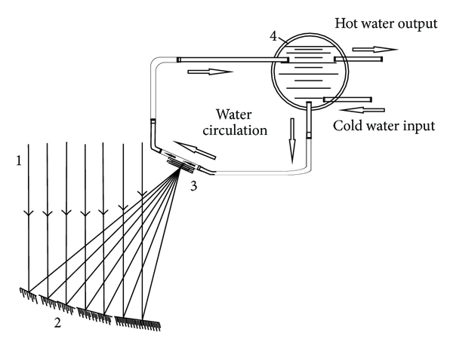
Heat exchanger design for Thermal/Electric generating unit
To come up with an optimal heat exchanger configuration, there are several configurations that can be done. However, the configurations can also be evaluated. This can be done by the use of commercial finite method software. When it comes to the flow chart, values that were gathered earlier should be used, and the temperature cooling plate should not go beyond 50 degrees Celsius, while the hot plate should be around 200 degrees Celsius. The heat exchange should always be designed to be simple, with a flat plate attached to the commercial pipes. In many cases, modeling results show that changes parameters such as hot plate location. 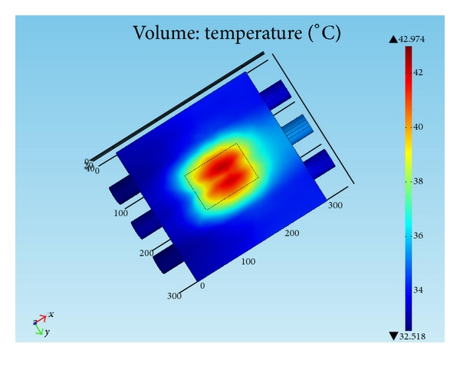
Investigation of CPV/TEG hybrid system
Materials and Methods
- Building a thermoelectric generator simulation method
- The analysis is done in the basement on three thermoelectric generator modules with a number of junctions, dimensions, and manufacture codes.
- Production of CAD components drawing and assembling of modules
- Performance of meshing process on CAD drawings of the resultant
- Impute of physical parameters for every component in the simulation program
- Establishment of heat transfer simulation for every module, which considered the thermal process that took place in the laboratory like conductive heat transfer. The figure below is a cross-sectional distribution of temperature in the junction on the upper side, thermoelectric generator module with the collar cell found on the top of the module (Li et al., 2017). 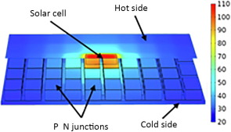
Temperature distribution in a TEG module with a 10 × 10 mm² solar cell attached to its hot side.
Validation
The open-circuit voltage outputs can be compared against the open-circuit voltage found in the datasheet of the manufacturer. In most cases, cold-site temperatures are fixed at a specific temperature of around 30 °C; white on the other side, cold-site temperatures are varied within a fixed temperature ranging between 50 °C and 250 °C. Finally, there is the extraction of open-circuit voltage, which is gotten from the datasheet of the manufacturer. Therefore, the simulation results for the thermoelectric generator should always match with the voltages measured in the datasheet.
Experimental Setup
It involves using a GaInP/GalnAs/Ge triple-junction photovoltaic cell with a ceramic base over a large area for dissipation of heat. Mostly, it uses a custom-solar simulator as the source of light. The source of the light is equipped with a honeycomb-type homogenizer, and it produces a homogenous light that is collimated from a Xenon lamp standard with light concentration ratios between 65 to 104 suns.
Simulated TEG open–circuit voltage plotted against datasheet values for the three TEGs at the cold side temperature of 30 °C.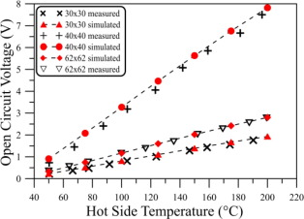
Conclusion
A passive cooling subsystem for incorporating thermoelectric is recommendable. Nevertheless, when it comes to dissipating excess heat from the solar cell, the thermoelectric generator uses waste heat to generate more power. The electrical output of the chosen thermoelectric generator modules can be stimulated by using the finite element method and the analysis of heat transfer. The stimulated output of every thermoelectric generator module is validated against the datasheet of the manufacturer, which is a demonstration of a good match with the obtained results from the experiments conducted. Furthermore, comparing CPV/TEG hybrid system with other simulation models obtained in every thermoelectric generator module presents a better position as a machine that has generated more energy even though it is faced with stiff competition (Tjahjono, 2017).

Reference
Allouhi, A., Kousksou, T., Jamil, A., Bruel, P., Mourad, Y., & Zeraouli, Y. (2015). Solar driven cooling systems: An updated review. Renewable and Sustainable Energy Reviews, 44, 159-181.
Chen, S., Zhu, L., Yoshita, M., Mochizuki, T., Kim, C., Akiyama, H., & Kanemitsu, Y. (2015). Thorough subcells diagnosis in a multi-junction solar cell via absolute electroluminescence-efficiency measurements. Scientific reports, 5(1), 1-6.
Ekins-Daukes, N. J., Sandwell, P., Nelson, J., Johnson, A. D., Duggan, G., & Herniak, E. (2016, September). What does CPV need to achieve in order to succeed?. In AIP Conference Proceedings (Vol. 1766, No. 1, p. 020004). AIP Publishing LLC.
Guerrero-Lemus, R., Vega, R., Kim, T., Kimm, A., & Shephard, L. E. (2016). Bifacial solar photovoltaics–A technology review. Renewable and sustainable energy reviews, 60, 1533-1549.
Li, W., Peng, J., Xiao, W., Wang, H., Zeng, J., Xie, J., & Zhang, L. (2017). The temperature distribution and electrical performance of fluid heat exchanger-based thermoelectric generator. Applied thermal engineering, 118, 742-747.
Lu, X., Yu, X., Qu, Z., Wang, Q., & Ma, T. (2017). Experimental investigation on a thermoelectric generator with a non-uniform hot-side heat exchanger for waste heat recovery. Energy Conversion and Management, 150, 403-414.
Makki, A., Omer, S., Su, Y., & Sabir, H. (2016). Numerical investigation of heat pipe-based photovoltaic–thermoelectric generator (HP-PV/TEG) hybrid system. Energy conversion and management, 112, 274-287.
Mathews, I., Kantareddy, S. N., Buonassisi, T., & Peters, I. M. (2019). Technology and market perspective for indoor photovoltaic cells. Joule, 3(6), 1415-1426.
Milichko, V. A., Shalin, A. S., Mukhin, I. S., Kovrov, A. E., Krasilin, A. A., Vinogradov, A. V., ... & Simovski, C. R. (2016). Solar photovoltaics: current state and trends. Physics-Uspekhi, 59(8), 727.
Paranthaman, M. P., Wong-Ng, W., & Bhattacharya, R. N. (Eds.). (2016). Semiconductor materials for solar photovoltaic cells (Vol. 218). Switzerland: Springer International Publishing.
Philipps, S. P., Bett, A. W., Horowitz, K., & Kurtz, S. (2015). Current status of concentrator photovoltaic (CPV) technology (No. NREL/TP-5J00-65130). National Renewable Energy Lab. (NREL), Golden, CO (United States).
Powell, K. M., Rashid, K., Ellingwood, K., Tuttle, J., & Iverson, B. D. (2017). Hybrid concentrated solar thermal power systems: A review. Renewable and Sustainable Energy Reviews, 80, 215-237.
Solanki, C. S. (2015). Solar photovoltaics: fundamentals, technologies, and applications. Phi learning pvt. Ltd.
Tjahjono, H. (2017). Comprehensive prediction of thermosyphon characteristics in reactor passive cooling system simulation loop FASSIP-01. Atom Indonesia, 43(3), 157-166.

